
FLUME

## Flume Home Directory
export FLUME_HOME=/usr/lib/flume/apache-flume-1.5.2-bin
export FLUME_CONF_DIR=$FLUME_HOME/conf
export FLUME_CLASSPATH=$FLUME_HOME/lib
export PATH=$PATH:$FLUME_HOME/bin
export FLUME_CLASSPATH="$FLUME_HOME/lib/flume-sources-1.0-SNAPSHOT.jar"

Topics covered in this document:

- Twitter Data Analytics – Example-1
- Introduction to FLUME
- Create FLUME Program – Example-2
- ←┘

++++++++++++++++++++++++++++++++++++++++++++++++++++++++++++++++++++++++++++++++++++++++++++++++++++

Example-1

1. Twitter Data Analytics
(http://www.thecloudavenue.com/2013/03/analyse-tweets-using-flume-hadoop-and.html)

In this doc, we will try to get Tweets using Flume and save them into HDFS for later analysis. Twitter service is free, but requires the user to register for the service. Cloudera wrote a three part series (1, 2 and 3) for Twitter Analysis using Hadoop, here explained, how to get data into HDFS using Flume and start doing some analytics using Hive.

Flume has the concepts of agents. The sources, sinks and the intermediate channels are the different types of agents. The sources can push/pull the data and send it to the different channels which in turn will send the data to the different sinks. Flume decouples the source (Twitter) and the sink (HDFS) in this case. Both the source and the sink can operate at different speeds; also it's much easier to add new sources and sinks. Flume comes with a set of sources, channels, sinks and new one can be implemented by extending the Flume base classes.

Precondition: the following software are already installed
- Hadoop 1.2.1
- Java 1.7
- CentOS 6.3
- Flume 1.5
- Hive
- Flume-sources-1.0-SNAPSHOT.jar //This jar file contains java-classes to pull the Tweets and save them into HDFS.

Step 1: The first step is to create an application in https://dev.twitter.com/apps/ and then generate the corresponding keys.

Consumer Key (API Key) CZdkh3sjmyhr6CLegKRZw3ojI
Consumer Secret (API Secret) dklEkQuZxshhcS4sKQPs9jiqKQjVzuxylJuBw1C6Ogh3FubeIa
Access Token 3186816422-fURMASRAFgVT7m7fikGeYBKXg1wDhsRgLO3HbbG
Access Token Secret 53Wq2DiKdsPAhgA906wpLibHEzzs7wGWxMwviQ1Ekqr8f

Access Level Read, write, and direct messages (modify app permissions)
Owner varmam540
Owner ID 318681642

Step 2: Download the flume-sources-1.0-SNAPSHOT.jar and saved in /usr/lib/flume/apache-flume-1.5.2-bin /lib folder; then add it to the flume class-path as shown below in the conf/flume-env.sh file

FLUME_CLASSPATH=" /usr/lib/flume/apache-flume-1.5.2-bin /lib/flume-sources-1.0-SNAPSHOT.jar"

[hduser@localhost conf]$ gedit flume-env.sh

## Enviroment variable can be set here.
JAVA_HOME=/usr/java/latest ##(murali-note: please give Java location of your system)

## Give Flume more memory and pre-allocate, enable remote monitoring via JMX
JAVA_OPTS=”-Xms500m –Xmx1000m –Dcom.sun.management.jmxremote”

## Note that the Flume conf directory is always included in the Classpath
#FLUME_CLASSPATH=” /usr/lib/flume/apache-flume-1.5.2-bin /lib/flume-sources-1.0-SNAPSHOT.jar”

+++Save and close the file. +++

Step 3: The conf/flume.conf should have all the agents (flume, memory and hdfs) defined as below

[hduser@localhost /usr/lib/flume/conf]flume.conf

TwitterAgent.sources = Twitter
TwitterAgent.channels = MemChannel
TwitterAgent.sinks = HDFS

TwitterAgent.sources.Twitter.type = com.cloudera.flume.source.TwitterSource
TwitterAgent.sources.Twitter.channels = MemChannel
TwitterAgent.sources.Twitter.consumerKey = <consumerKey> [murali note: modify these values with twitter details]
TwitterAgent.sources.Twitter.consumerSecret = <consumerSecret>
TwitterAgent.sources.Twitter.accessToken = <accessToken>
TwitterAgent.sources.Twitter.accessTokenSecret = <accessTokenSecret>

TwitterAgent.sources.Twitter.keywords = hadoop, big data, analytics, bigdata, cloudera, data science, data scientiest, business intelligence, mapreduce, data warehouse, data warehousing, mahout, hbase, nosql, newsql, businessintelligence, cloudcomputing

TwitterAgent.sinks.HDFS.channel = MemChannel
TwitterAgent.sinks.HDFS.type = hdfs
TwitterAgent.sinks.HDFS.hdfs.path = hdfs://localhost:54310/user/flume/tweets/ [muraliNote: name-node]
TwitterAgent.sinks.HDFS.hdfs.fileType = DataStream
TwitterAgent.sinks.HDFS.hdfs.writeFormat = Text
TwitterAgent.sinks.HDFS.hdfs.batchSize = 1000
TwitterAgent.sinks.HDFS.hdfs.rollSize = 0
TwitterAgent.sinks.HDFS.hdfs.rollCount = 10000

TwitterAgent.channels.MemChannel.type = memory
TwitterAgent.channels.MemChannel.capacity = 10000
TwitterAgent.channels.MemChannel.transactionCapacity = 100

‘++++++ save and close the file and see the twitter account details below+++

My twitter application details, here it is not covered, see twitter_account_application_creation.doc
Consumer Key (API Key) CZdkh3sjmyhr6CLegKRZw3ojI
Consumer Secret (API Secret) dklEkQuZxshhcS4sKQPs9jiqKQjVzuxylJuBw1C6Ogh3FubeIa
Access Token 3186816422-fURMASRAFgVT7m7fikGeYBKXg1wDhsRgLO3HbbG
Access Token Secret 53Wq2DiKdsPAhgA906wpLibHEzzs7wGWxMwviQ1Ekqr8f
Access Level Read, write, and direct messages (modify app permissions)
Owner varmam540
Owner ID 318681642

The consumerKey, consumerSecret, accessToken and accessTokenSecret have to be replaced with those obtained from https://dev.twitter.com/apps And, TwitterAgent.sinks.HDFS.hdfs.path should point to the NameNode and the location in HDFS where the tweets will go to.

The TwitterAgent.sources.Twitter.keywords value can be modified to get the tweets for some other topic like football, movies etc.

Step 4: Start flume using the below command

[hduser@localhost flume]$ jps

[hduser@localhost flume]$ start-all.sh //to start all 5 daemons

[hduser@localhost flume]$ bin/flume-ng agent --conf ./conf/ -f conf/flume.conf -Dflume.root.logger=DEBUG,console -n TwitterAgent

(Murali note: some time, the above command may not work as system may not read class-path, hence give explicitly as shown)

[hduser@localhost ~]$ bin/flume-ng agent --conf ./conf/ -f conf/flume.conf -Dflume.root.logger=DEBUG,console -n TwitterAgent -c /usr/lib/flume/apache-flume-1.5.2-bin/lib/flume-sources-1.0-SNAPSHOT.jar

After a couple of minutes the Tweets should appear in HDFS.

Step 5: See the tweets in hdfs

Open browse and type name node url, http://localhost.localdomain:50070/dfshealth.jsp
Click ‘Browse the file system’ link
Click ‘user’
Click ‘flume’
Click ‘tweets’

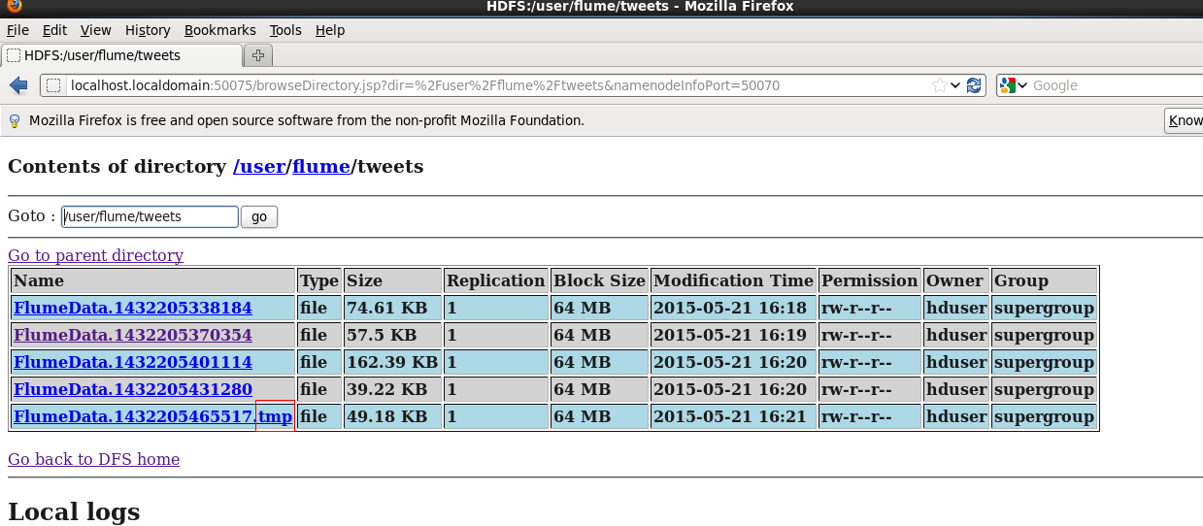

Click any file to open the file and see the tweets
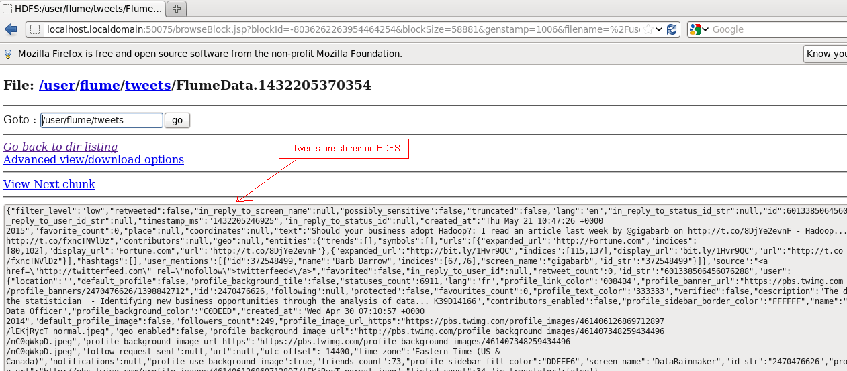

Step 6: Here on words, need to load data into Hive tables and do the remaining process

++++++++++++++++++++++++++++++++++++++++++++++++++++++++++++++++++++++++++++++++++++++++++++++++++++

Introduction to FLUME

Apache Flume is a system used for moving massive quantities of streaming data into HDFS. Collecting log data present in log files from web servers and aggregating it in HDFS for analysis, is one common example use case of Flume.

Flume supports multiple sources like –
- 'tail' (which pipes data from local file and write into HDFS via Flume, similar to Unix command 'tail')
- System logs
- Apache log4j (enable Java applications to write events to files in HDFS via Flume).

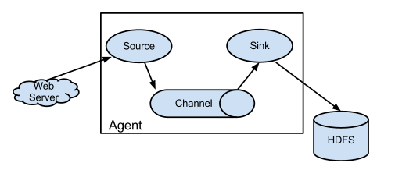
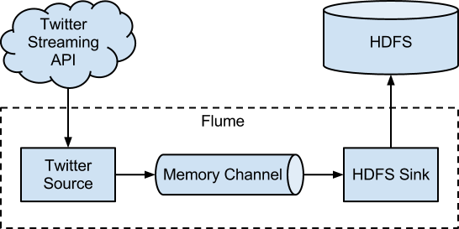

Data Flow in Flume

A Flume agent is a JVM process which has 3 components -Flume Source, Flume Channel and Flume Sink- through which events propagate after initiated at an external source .
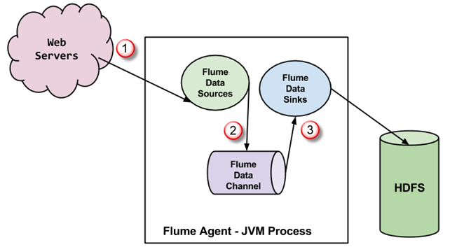

- In above diagram, the events generated by external source (WebServer) are consumed by Flume Data Source. The external source sends events to Flume source in a format that is recognized by the target source.

- Flume Source receives an event and stores it into one or more channels. The channel acts as a store which keeps the event until it is consumed by the flume sink. This channel may use local file system in order to store these events.

- Flume sink removes the event from channel and stores it into an external repository like e.g., HDFS. There could be multiple flume agents, in which case flume sink forwards the event to the flume source of next flume agent in the flow.

Some Important features of FLUME

- Flume has flexible design based upon streaming data flows. It is fault tolerant and robust with multiple failover and recovery mechanisms. Flume has different levels of reliability to offer which includes 'best-effort delivery' and an 'end-to-end delivery'. Best-effort delivery does not tolerate any Flume node failure whereas 'end-to-end delivery' mode guarantees delivery even in the event of multiple node failures.

- Flume carries data between sources and sinks. This gathering of data can either be scheduled or event driven. Flume has its own query processing engine which makes it easy to transform each new batch of data before it is moved to the intended sink.

- Possible Flume sinks include HDFS and Hbase. Flume can also be used to transport event data including but not limited to network traffic data, data generated by social-media websites and email messages.

Since July 2012, Flume is being released as Flume NG (New Generation), as it differs significantly from its original release, as known as Flume OG (Original Generation).

Sqoop | Flume | HDFS
Sqoop is used for importing data from structured data sources such as RDBMS. | Flume is used for moving bulk streaming data into HDFS. | HDFS is a distributed file system used by Hadoop ecosystem to store data.
Sqoop has connector based architecture. Connectors know how to connect to the respective data source and fetch the data. | Flume has agent based architecture. Here, code is written (which is called as 'agent') which takes care of fetching data. | HDFS has a distributed architecture where data is distributed across multiple data nodes.
HDFS is a destination for data import using Sqoop. | Data flows to HDFS through zero or more channels. | HDFS is an ultimate destination for data storage.
Sqoop data load is not event driven. | Flume data load can be driven by event. | HDFS just stores data provided to it by whatsoever means.
In order to import data from structured data sources, one has to use Sqoop only, because its connectors know how to interact with structured data sources and fetch data from them. | In order to load streaming data such as tweets generated on Twitter or log files of a web server, Flume should be used. Flume agents are built for fetching streaming data. | HDFS has its own built-in shell commands to store data into it.  HDFS can not import streaming data

www.guru99.com

For executing the Flume – twitter example:
[hduser@localhost ~]$

flume-ng agent --conf /usr/lib/flume/apache-flume-1.5.2-bin/conf/ -f /usr/lib/flume/apache-flume-1.5.2-bin/conf/flume.conf -Dflume.root.logger=DEBUG,console -n TwitterAgent

flume-ng agent
--conf /usr/lib/flume/apache-flume-1.5.2-bin/conf/
-f /usr/lib/flume/apache-flume-1.5.2-bin/conf/flume.conf
-Dflume.root.logger=DEBUG,console
-n TwitterAgent

]$bin/flume-ng agent –conf ./conf/ -f conf/flume.conf -Dflume.root.logger=DEBUG,console -n TwitterAgent

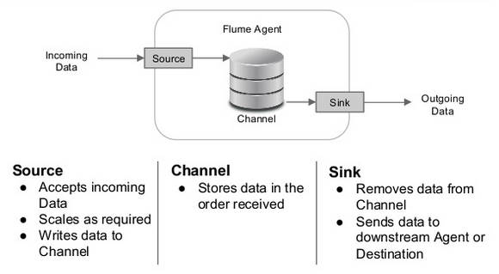

]$ flume-ng version

$ /usr/bin/flume-ng agent -n $agent_name -c conf -f conf/flume-conf

$/bin/flume-ng agent -n TwitterAgent -c /usr/lib/flume/apache-flume-1.5.2-bin/conf/ -f /usr/lib/flume/apache-flume-1.5.2-bin/conf/flume.conf

$ /bin/flume-ng agent --conf conf --conf-file example.conf --name a1 -Dflume.root.logger=INFO,console

$ /bin/flume-ng agent --conf /usr/lib/flume/apache-flume-1.5.2-bin/conf/ -Dflume.root.logger=INFO,console -n TwitterAgent -f /usr/lib/flume/apache-flume-1.5.2-bin/conf/flume.conf

$ bin/flume-ng agent --conf /usr/lib/flume/apache-flume-1.5.2-bin/conf/ -f /usr/lib/flume/apache-flume-1.5.2-bin/conf/flume.conf -Dflume.root.logger=DEBUG,console -n TwitterAgent

++++++++++++++++++++++++++++++++++++++++++++++++++++++++++++++++++++++++++++++++++++++++++++++++++++

Create FLUME Program – Example-2

Prerequisites:
- This tutorial is developed on Linux - Ubuntu operating System.
- You should have Hadoop
(Version 2.2.0 used for this tutorial) already installed and is running on the system.
- You should have Java (Version 1.8.0 used for this tutorial) already installed on the system.
- You should have set JAVA_HOME accordingly.
- Maven

Before starting, with the actual process, we have changed user to 'hduser' (user used for Hadoop).

hduser@localhost ~] su - hduser
Steps:

Flume, library and source code setup

Create a new directory with name 'FlumePractice'
[hduser@localhost ~]sudo mkdir FlumePractice

Give read, write and execute permissions sudo chmod -R 777 FlumeTutorial
[hduser@localhost ~] chmod -R 777 FlumePractice
[hduser@localhost ~] cd FlumePractice
[hduser@localhost FlumePractice] pwd
/home/hduser/ FlumePractice

Step-2

Copy files MyTwitterSource.java and MyTwitterSourceForFlume.java in this directory.

[hduser@localhost FlumePractice] ls
MyTwitterSource.java
MyTwitterSourceForFlume.java

[hduser@localhost FlumePractice]

Step-3
<Installation Directory of flume> is: /usr/lib/flume/apache-flume-1.5.2-bin

Step-4 Flume library setup

Copy
twitter4j-core-4.0.1.jar,
flume-ng-configuration-1.4.0.jar,
flume-ng-core-1.4.0.jar,
flume-ng-sdk-1.4.0.jar

to /usr/lib/flume/apache-flume-1.5.2-bin/lib/ (murali-note: here versions are differ)

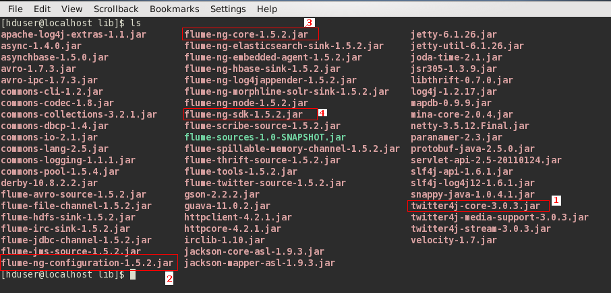

It is possible that either or all of the copied JAR will have execute permission. This may cause issue with the compilation of code. So, revoke execute permission on such JAR.
In my case, twitter4j-core-4.0.1.jar was having ‘execute’ permission. So I revoked it as below-

[hduser@localhost FlumePractice] cd /usr/lib/flume/apa…/lib
[hduser@localhost lib]sudo chmod -x twitter4j-core-4.0.1.jar

After this command give 'read' permission on twitter4j-core-4.0.1.jar to all.
sudo chmod +rrr /usr/local/apache-flume-1.4.0-bin/lib/twitter4j-core-4.0.1.jar

Load data from Twitter using Flume
Open new terminal

1. Go to directory containing source code files in it.
[hduser@localhost FlumePractice]

2. Set CLASSPATH to contain <Flume Installation Dir>/lib/* and ~/FlumePractice/flume/mytwittersource/*

[hduser@localhost FlumePractice]

export CLASSPATH="/usr/lib/flume/apache-flume-1.5.2-bin/lib/*:~/FlumePractice/flume/mytwittersource/*"

[hduser@localhost FlumePractice] echo $CLASSPATH ←┘ //to know the classpath
"/usr/lib/flume/apache-flume-1.5.2-bin/lib/*:~/FlumePractice/flume/mytwittersource/*"

[hduser@localhost FlumePractice]

3. Compile source code using command
[hduser@localhost FlumePractice] javac -d . MyTwitterSourceForFlume.java MyTwitterSource.java

++++++++++++++++++++++++++++++++++++++++++++++++++++++++++++++++++++++++++++++++

